***Flipkart***

**Pages:**

> Home page > Login / Sign up Page Product Page > Buying options > Payment Gateway

**Page Structure:**

**Login Page:**

A login page that allows users to log in using mail id & password and can sign up for creating a new account.

**Home page:**

Link to Profile Page, Wishlist, logout, cart, etc

**Profile page structure:**

1. Personal detail
2. Logout
3. Help & Support
4. Search bar
5. Cart
6. Navigation for product categories
7. Offers etc

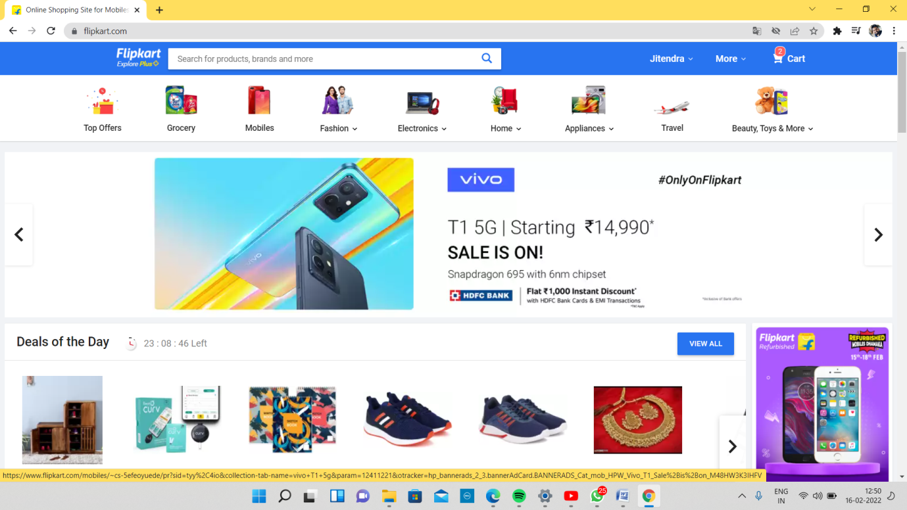

**Product page:**

* Product Cards
* Add to cart option
* Buy Now

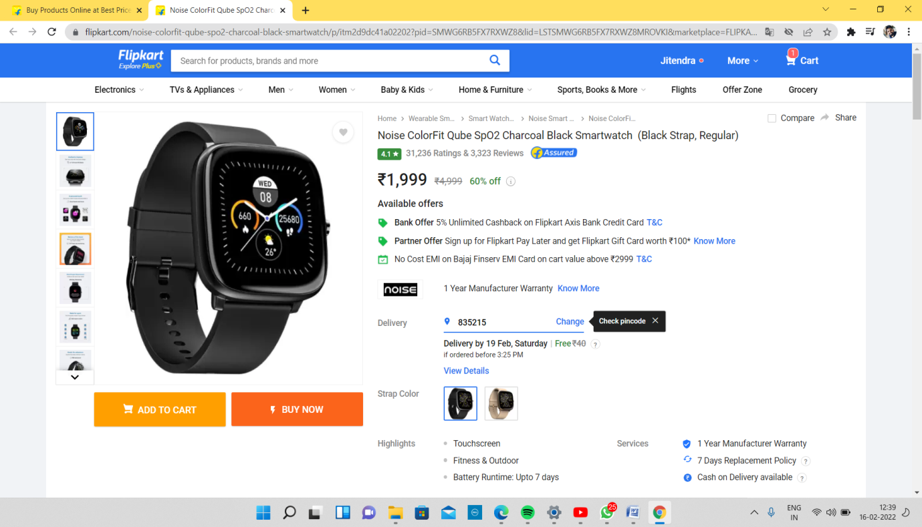

**Customer Address :**

Customers can give work addresses or residential addresses. Add new address option is also available.

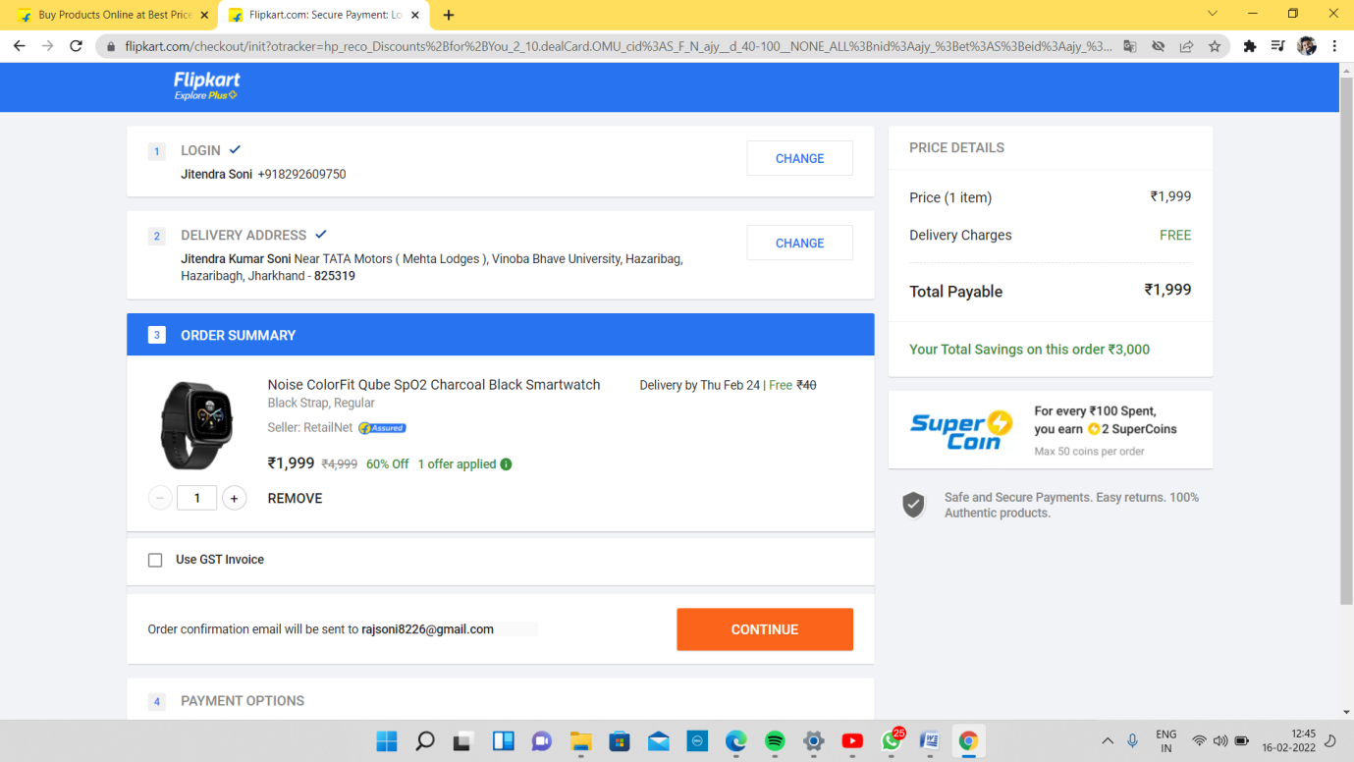

**Payment method:**

COD / EMI / Debit card, Credit card, UPI etc.

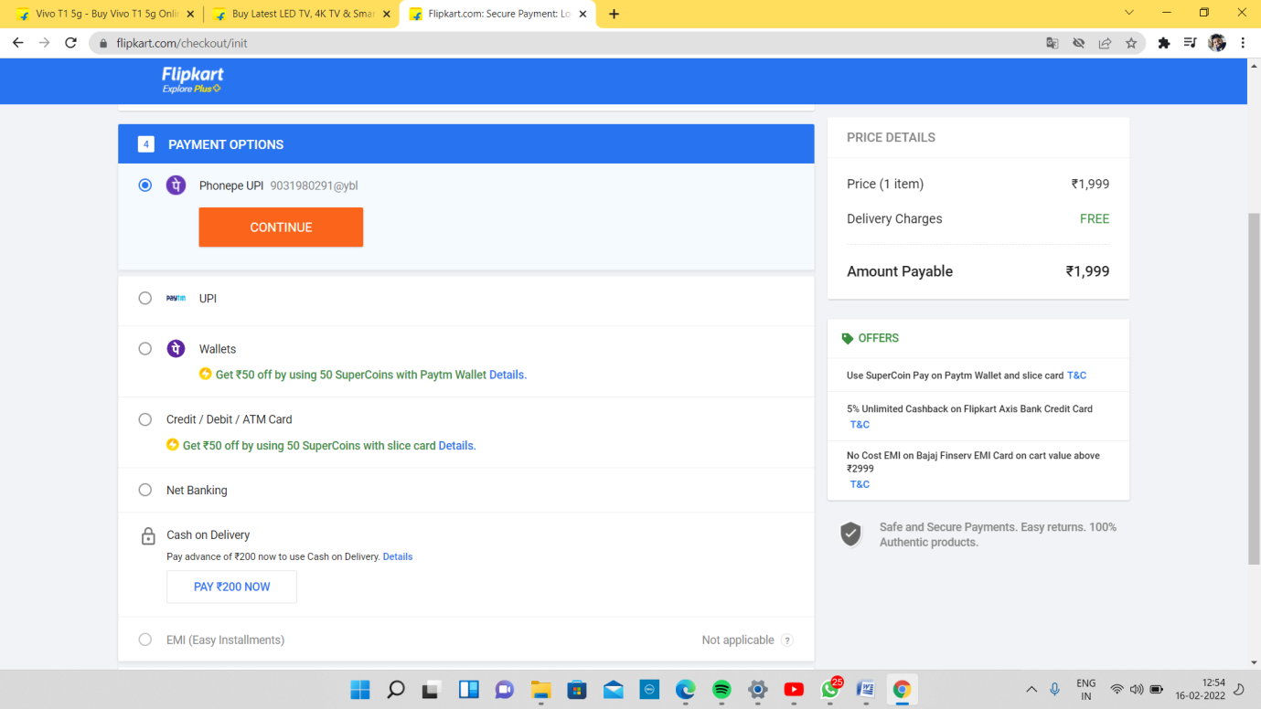

**Payment Gateway:**

**Basics Features:**

**Login page:**

Login Id (*Required)

Password (*Required)

Login button

**Sign up page:**

Form --> takes personal details as input

Name

Mobile number

Mail id

Address

Sign up button

**Home page:**

* Search bar to search brands or by product name
* Link to the profile/account page etc.

**Items in cart:**

Shows products added to cart & Option to edit them.

**Product Page and Filters:**

The product page consists of different variety of products based on data collected.